**Library Management System**

**Project Report By**

**Muhammad Noman**

**Table of Contents**

1. Introduction 3

2. Scope 3

3. Module Description 3

4. Hardware/Software Requirements 3

5. Screen Shots 3

**1.INTRODUCTION:**

A library management system is software that is designed to manage all the functions of a library. It helps librarian to maintain the database of new books and the books that are borrowed by members along with their due dates. This system completely automates all your library's activities. The system is an automated Library Management System. Through our software users can add members, add books, search members, search books, update information, edit information, and borrow and return books in quickly time.

1.1 ACTIVITY:

* Search for a book.
* Add/Delete books.
* View user and book details.
* Issue books.
* Return books.
* Maintain user and book details.

1.2 BENEFITS

A review of the literature reveals that a computerized library management system will:

* Help to improve library services.
* Help the Liberians with management information.
* Help the librarian in reporting on the various operations of the library.
* Increase the rate at which Tasks are completed accurately.

1.3 DIAGRAM

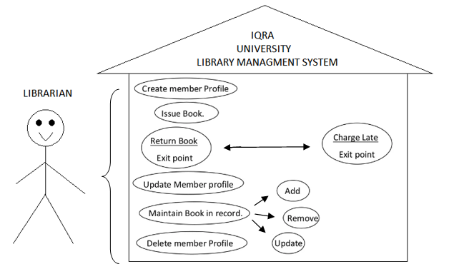

**2.SCOPE**

The purpose is to automate the existing manual system by the help of computerized equipment’s and full-fledged computer software, fulfilling their requirements, so that their valuable data/information can be stored for a longer period with easy accessing and manipulation of the book records. Almost in LIBRARY MANAGEMENT the records of members, new book Entry, their details, Member Entry, member Enquiry, Book Enquiry, Book Return register etc. are maintained and manipulated. Generally, all these works are done and managed manually hence leading to the chances of human errors that may create some problems. They are used in public and private libraries as well. The rise in demand for library management software is projected to increase the sales growth of the global Library Management Software market in the forecast period, set between 2021 and 2031.

**3.MODULE DESCRIPTION:**

1. We are using an object as a class to save data in one line by implementing the Serializable which is the mechanism of converting the state of an object into a byte stream in a form of String.
2. Using Filing to store an object.
3. Using ObjectOutputStream to read an object from we file which we storing while.
4. Using ObjectInputStream class of collection framework of java to write an object.
5. Using LinkedList as a data structure which allow to iterate data freely in a form of object then that list address anddata writes into the file.
6. Using ListIterator to read an object in readable form.
7. Using LocalDate Collection frame work to assigning issue and due date data.
8. Using JButton, JtextField, JtextArea, ActionListener, JFrame, SetVisble method in Jform to Create Graphical user Interface of this Application.

**4.HARDWARE/SOFTWARE REQUIREMENTS**

Operating System: Windows XP, Windows Vista, Windows 8, Windows 8.1, Windows 10.

Language: Java.

IDE: NetBeans IDE.

Storage: 4GB RAM and 120GB ROM

Processor: Intel Pentium 4 and above

**5.Screenshoots**

